The Band Map

Geoff Anderson G3NPA, Jim Hargrave W5IFP and Aki Yoshida JA1NLX

1.0 GENERAL

The BandMap is an additional or alternative way to display received DX Spots information in frequency order. The display can be used in the same way as the spot table in that clicking on a spot (callsign) will QSY the radio to that frequency and mode. It will also display pseudo spots (see the topic Pseudo DX Spots).

To activate the basic BandMap window select the Logger32 Main menu View | Show BandMap menu items.

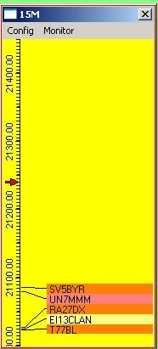

TBM_1

The frequency scale to the left of the window is determined by:

  - The band currently in use on the radio;
  - The frequency range in the Band/Mode table; and,
  - The scaling as set by the user. (see Config menu)

In the example shown there is a red arrow at 21.240 and this represents the actual radio frequency set. The marker position will change as the VFO is rotated

Clicking on the scale will QSY the radio to the frequency under the cursor. Note: If you are using the AFSK freq offset option (see Adjust DX Spots for Audio Frequency), then the VFO position cursor will not always align with the actual spot flag, the error being the amount of audio offset used.

Spot data appears to the right of the frequency scale (see Operational notes below)

2.0 MENU BAR

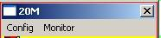

TBM_9

Note: For the Bandmap to work as described above, the Bandmode selection panel must be set to have the "Band from Bandplan" option selected (see the Logbook Entry window topic).

2.1 Config Menu

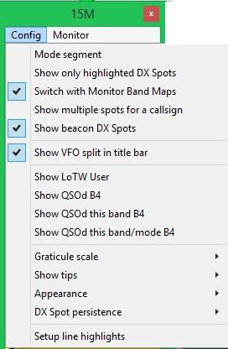

TBM_7

2.1.1 Mode Segment

The frequency scale can be made to change for each mode segment (as defined in the Band/Mode table). If this option is selected, tuning the radio through the band will cause the frequency scale to change and fill the available space with the max and min frequencies for the particular section (21.200 to 21.450 in this case). The title bar will denote the mode segment, as shown below.

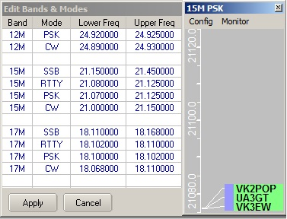

New TBM_4

When you tune into the adjacent mode section the scale will change again. Note that if a mode section has a narrow bandwidth, then it is quite possible that the frequency scale may be devoid of any numbers for this section.

2.1.2 Show colored DX Spots

The spot background colour may be turned on and off with this option. The colours are determined by those set in the Worked/Confirmed colour selection table (right click on the DX Spot window and select Setup | Appearance | Worked/Confirmed Colors)

2.1.3 Switch with Monitor Bandmaps

Please see the Monitor subsection below.

2.1.4 Show multiple spots for a callsign

This option will allow logger32 to display all spots for a callsign provided the spots refer to different frequencies. This is useful if the user has set up a band map to look at several frequency bands all at once (say 2 to 30 MHz) and wants to track the operation of a dxpedition. If the option is deselected then the callsign is only allowed to appear once in the listing and it will display for the last posted frequency.

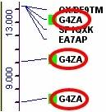

TBM_6

2.1.5 Show VFO split in title bar

When the radio is operating in split mode, this option displays the up/down split differential in the title bar. This is expressed in kHz.

Note: This only works for radios that report VFO-B frequency during polling.

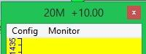

TBM_18

2.1.6 Show LotW User

Logger32 has the capability of recognising a DX spot station who is known to use LotW (see the topic DX Spots Window). A colored highlight to the left of the DX callsign in the BandMap windows indicates a station that uses LotW. This menu item enables that option. Note that each bandmap carries this option separately.

Information for setting the highlight color and the uploading of the necessary LotW user data is given in the topic DX Spots wIndow

2.1.7 Show QSOd this band before

Here the user can select to display if the station has been worked before. This is indicated by a colored highlight to the left of the displayed callsign.

The user has three options

  - to show stations QSOd before on any band
  - to show stations QSOd before on the particular band/mode combination, or
  - to show neither.

2.1.8 Graticule Scale

The user may select the most appropriate scaling for the display/freq range for the standard graticule. Note that different scaling may be used for each of the frequency bands as defined in the Band/Mode table.

The code has built-in protection to prevent frequency text from overwriting other frequencies. For example, you cannot show the 10M band showing the frequency every 10 KHz as it won't fit in.

2.1.9 Show Tips

Gives the user the choice of showing the mouse-over tool tips in full or reduced detail, with or without the spot elapsed time displayed.

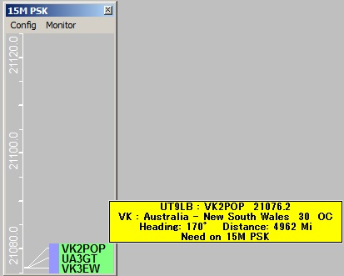

New TBM_12

2.1.10 Appearance

This option allows the user to select fonts and color combinations for the display, to suit the user's taste.

In addition, the user can select the option to mark the DX spot as someone who they have worked before on this band or on this band/mode combination. When such a match occurs, a small "x" precedes the callsign in question.

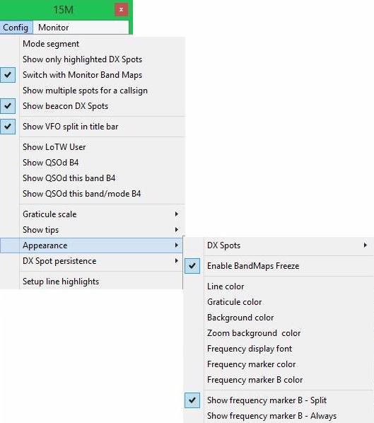

TBM_13

Important Note: This feature works using information obtained from the current bandplan, the logbook and the DXSpot frequency. This means that there are numerous ways in which the derived information could be in error. If used with care it could be a useful function to have switched in during DXpeditions and/or contests. Use at your own risk.

Selecting "Show frequency marker B Split" will display a VFO-B arrow on the frequency scale when the radio is in split mode.

Selecting "Show frequency marker B-Always" will display VFO-B frequency regardless of operating mode.

Note: The above options only works for radios that report VFO-B frequency during polling.

2.1.11 DX Spot Persistence

This option allows the user to select the amount of time the spots will remain visible, from 5 minutes to no time limit. The display timing is taken from the time reported in the spot details, not the time the data was actually placed on the screen. A DX spot reported at 12:01 and using a 5 min persistence, will remain visible until 12:06 and then disappear. This filtering does not destroy the data. To see a spot that might only just have been removed from the BandMap, simply increase the persistence time and it will re-appear.

Operational note: If you perform a SH/DX request, then only those spots that fall within the persistence timing window will be displayed.

2.1.12 Setup Line highlights

You can set the bandwidth and color of the highlight lines that join the frequency graticule and the list of DX Spots.These are set to match the reported radio mode that appears in the Logbook Entry window. Bandwidth is in Hz and defaults to 2400 Hz if there is no mode to match the radio mode As example; If CW is set to 300 Hz, lines +/- 150 Hz will be highlighted.

Note: The Receiver bandwidth is based on the reported Radio mode. The user can configure different bandwidth settings based on the actual radio mode: CW-N, CW-R, DATA-USB, and DATA-LSB, etc.

The user can identify band segments of personal interest (beacons, RTTY, BPSK, etc.) and highlight the lines that connect the graticule to the DX Spot in a different color. The user enters the upper/lower limit of whichever little piece of the band he/she wants to highlight.

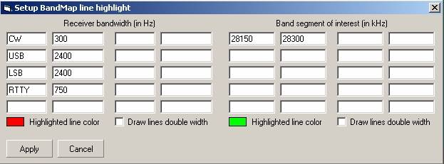

TBM_17

2.1.13 Zoom

The zoom function allows the user to select a particular section of the BandMap that may be of interest and to expand the displayed scale. Starting in Logger32 version 3.46 the Zoom menu has been removed and the Zoom function is now dynamic by scroll wheel action.

To activate this Zoom function, rrolling the mouse scroll wheel to the left of the list of callsigns will expand the main BandMap frequency scale. This method will expand the entire scale with concentration near the radio VFO frequency.

Note: Normal rotation of the mouse wheel will result in a 10Khz increment per click. To speed up the zoom action, roll the Mouse wheel while pressing The <Shift> key will zoom at 100kHz per wheel click.

You can move the vfo frequency with a left-click in the frequency scale near the point of interest. This will set the radio VFO at this point, indicated by the red arrow. Scroll the mouse wheel forward to expand the scale. As soon as the scale starts to expand it will change color. Scrolling the mouse wheel backwards will re-compress the scale. If the scale is compressed back to the point that it covers the full band, the frequency scale will revert back to the original color.

Note: The scroll zoom is inhibited if the ?Mode segment? option is selected,

Below is a sample of this action. The left side is a normal display and the right shows the scale expanded.

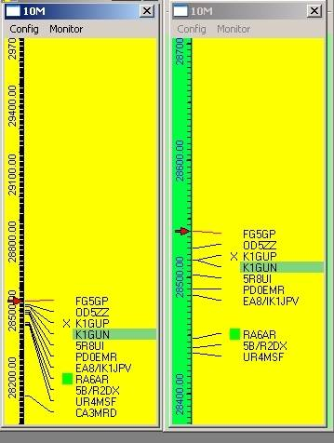

TBM_15

The Zoom background color is user selected by opening the "Appearance" sub-menu.

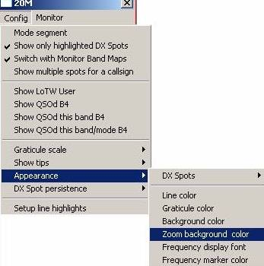

TBM_16

2.2 Monitor

Ten monitor Band Map windows are available to monitor. Band Map windows are available to allow the user to monitor activity on bands other than the one currently being used (for example; a permanent activity monitor for 6M and 10M regardless of what/where the operator is doing). Clicking on the "Monitor" menu option on the main Band Map will produce the additional display menu as shown below.

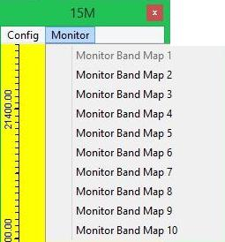

TBM_10

The user can click on a DX Spot on the Monitor Band Map and the Radio (if connected) and the Logbook Entry window will QSY to the frequency/mode. The Monitor Band Map will switch when the user changes bands on the radio, or the radio changes band for whatever reason (clicking on a DX spot, clicking on a Monitor BandMap, or whatever) to the band the radio was on (before the QSY) provided the "Switch with Monitor Bandmaps configuration" option is checked. If this option is unchecked, then the monitor windows will not change over with the main bandmap and will therefore continue to display spots for the selected band.

2.2.1 Config Menu

All config settings for the Monitor Band Map are identical to those of the main except the Highlight line is not applicable.

2.2.2 Band

It is here where the user selects the band to monitor. Note that the bands listed here are derived from the BandMode table and will differ according to user preferences and setup.

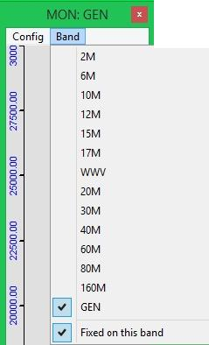

TBM_8

2.2.3 Operational Notes

One of the tips given is to insert a statement in the BandMode table to define the whole spectrum of the radio and call the mode GEN (see Tips, Tricks & Troubleshooting Cluster/DXSpot window/Bandmap). If you have this set up then a bandmap can display all the spots received over the full spectrum of the radio as shown below.

In versions of Logger32 from 3.13 onwards if the GEN freq spread is more than 30MHz then the main graticule is not drawn. If the GEN freq spread is less than 30MHz then the main graticule is drawn at 1MHz increments.
General note

It is recommended that the "Mode Segment" Config option be turned off in the main bandmap window for cases when the radio is tuned to a GEN frequency (as this speeds up the redraw of the window)

for cases when the radio is tuned to a GEN frequency (as this speeds up the redraw of the window)

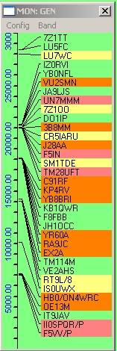

TBM_11

2.2.4 Removal of Unwanted Spots

To match up with the same facility available on the DX Spots window, individual spots on the Band Map can be deleted/removed if so desired. A simple right-click on the appropriate DX spot flag will bring up the menu below, from which one can then delete the flag (K4CY in TBM_14 below). If you do not click on a flag, the "Remove xxxxx" DX spot menu item will not appear.

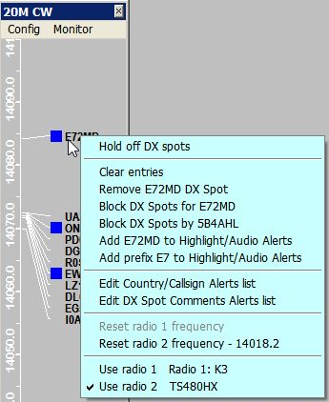

TBM_14

Note: Removal of the flag will also ensure the removal of the spot from the DX Spots window and DX Spots map. If the same station is "spotted" again following your deletion, then the report will of course re-appear.

2.2.5 Blocking of un-wanted spots for a specific callsign

In the same way as is possible in the DX Spots window, it is possible to block spots for a specific callsign. Having right-clicked on a selected callsign, the option is then presented to block DX Spots for that call. Note that the "spots by xxxxx" menu option indicates the callsign of the person reporting the spot.

2.2.6 Highlight/Audio alerts and Alerts list

Details are described in the topic DX Spots window.

3.0 TITLE BAR APPEARANCE

3.1 In-Focus Color

The BandMap and Monitor BandMap window title bars are always shown with the “in focus” color even when they are not actually in focus. The Band, Mode and Split Alert in the title bar are still clearly visible even when the window is not in focus. The following figure (TBM_19) shows an example where the focus is in CW Machine window, however the BandMap window looks as if it is also in focus.

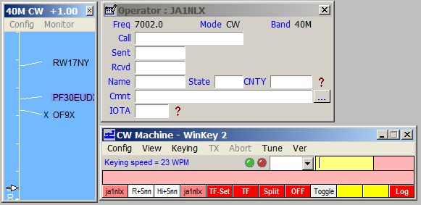

TBM_19

3.2 “I’m lost” message on the BandMap Title bar

This message appears if you ask Logger32 to do something that is not configured in the BandPlan, (like 30M SSB) then it will default to 20M frequencies on the frequency scale and 20M DX spots are displayed on the BandMap.

